|  |  |
| --- | --- |
| **Ex.No : 9** | **VM MIGRATION USING XEN SERVER** |
| **17.05.2022** |

Aim:

To migrate the virtual machine from one server to the another server using Xen Server.

Procedure:

STEP 1 : install xen server

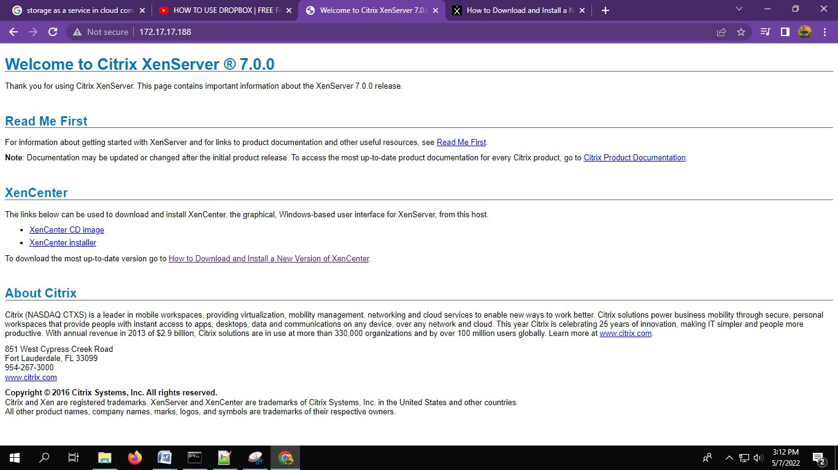

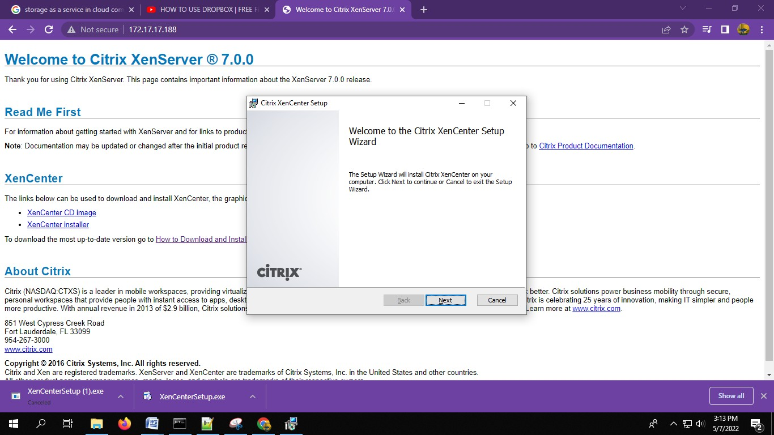

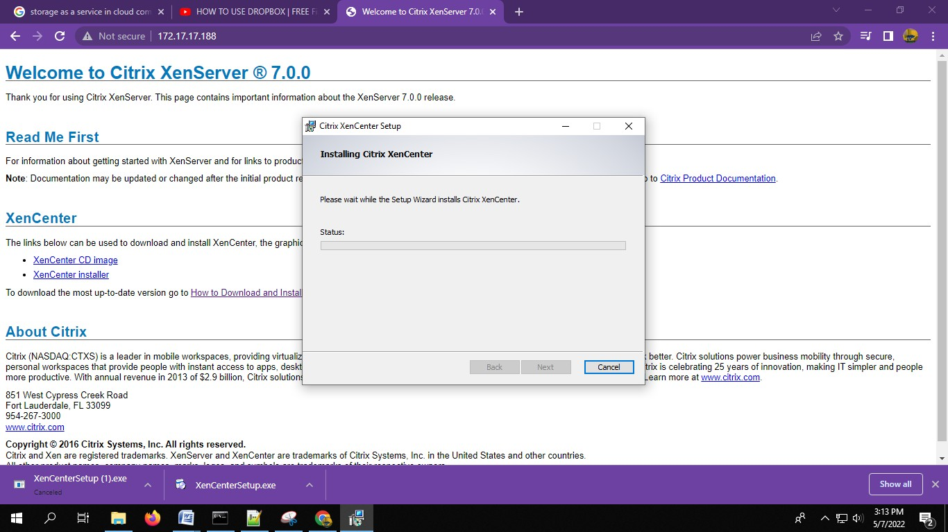Step 2 : Install xen server click next , next .

Step 3 : open xen server and give add a server , give appropriate server ip and login credentials.

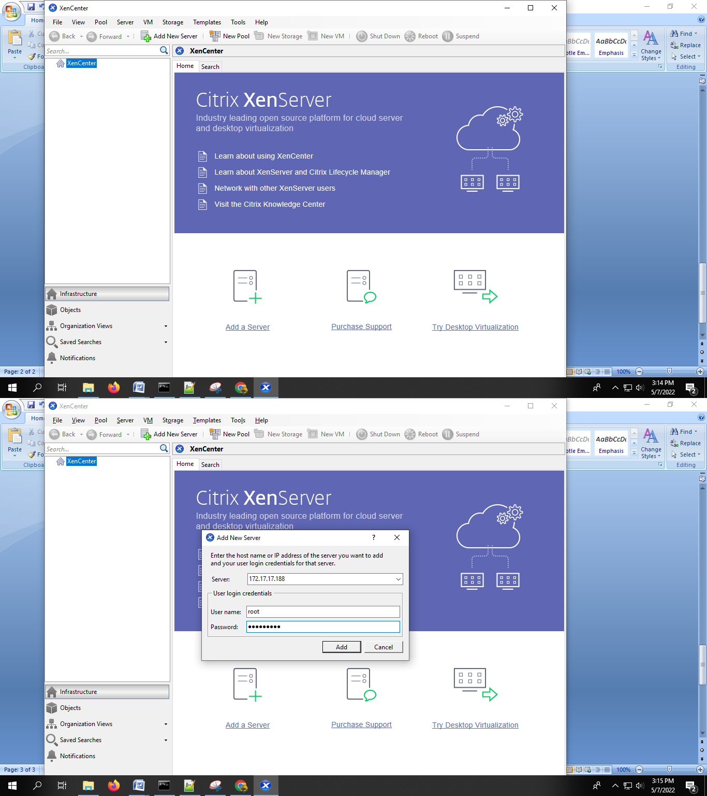

Step 4 : give save and restore connection state and give ok , give next .,it creates xenserver1.

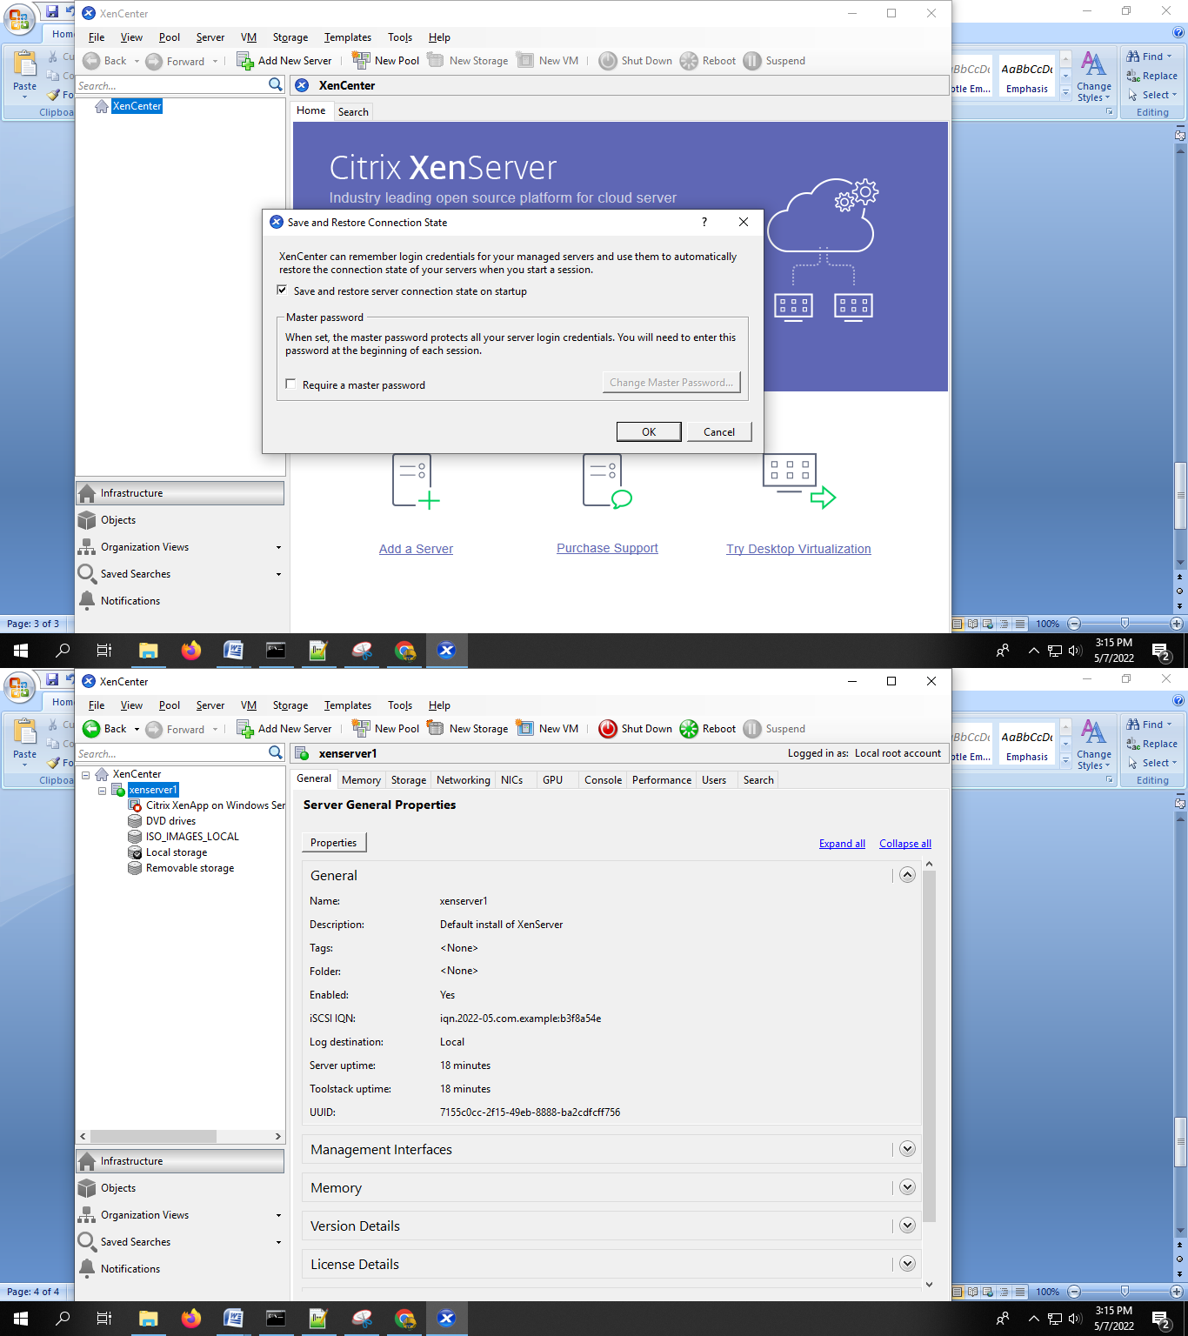

Step 5 : right click xenserver1 , click new VM and give ubuntu 12.04 as template , next , give ur VM name in name column.

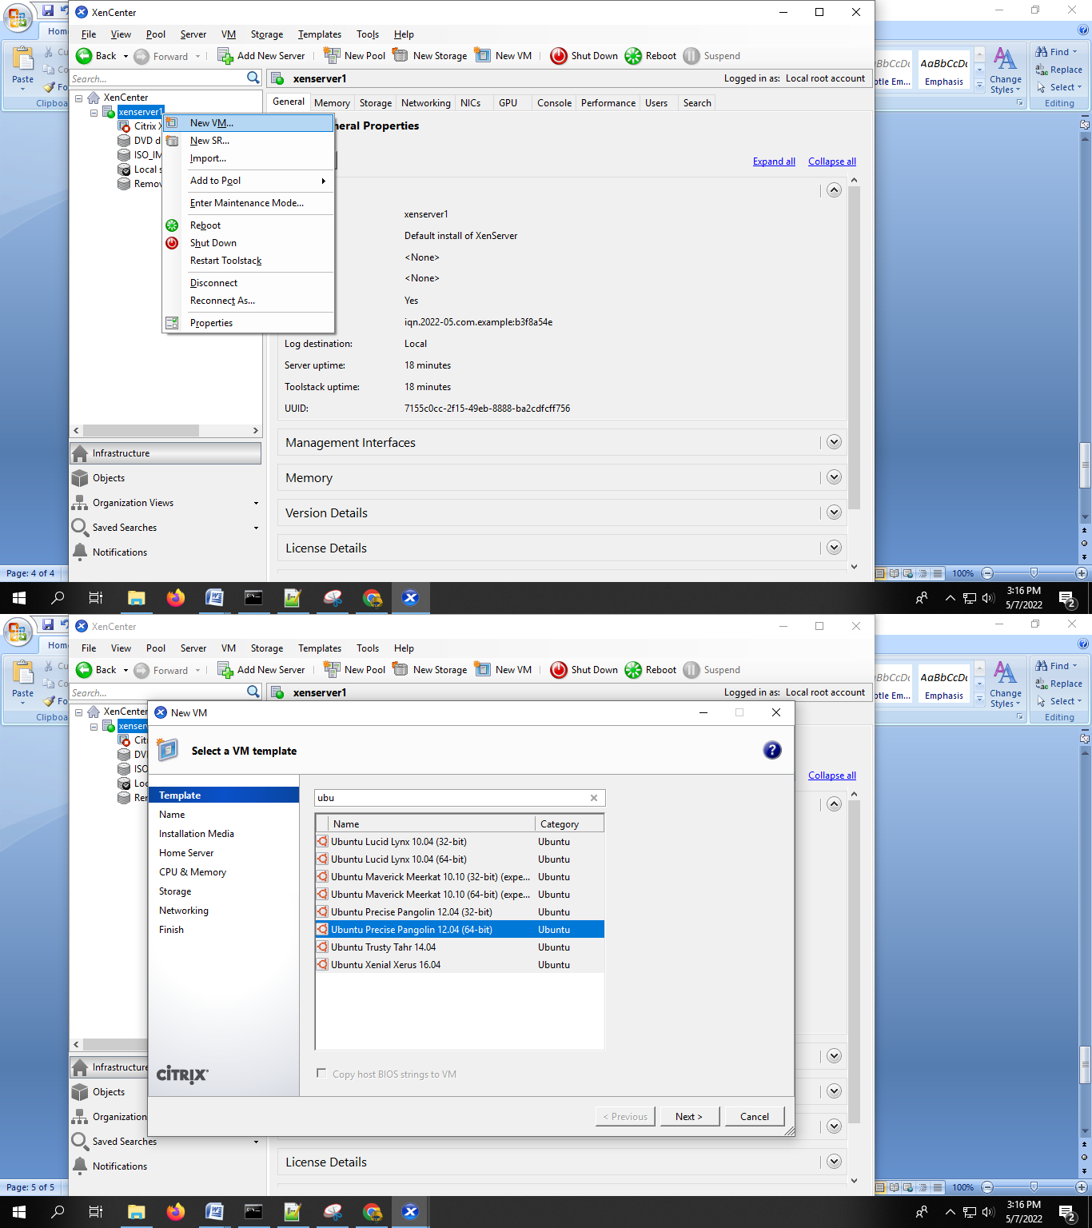

Step 6 : give ubuntu12.iso in install from ISO library. Give next , it creates a VM that you given the name.

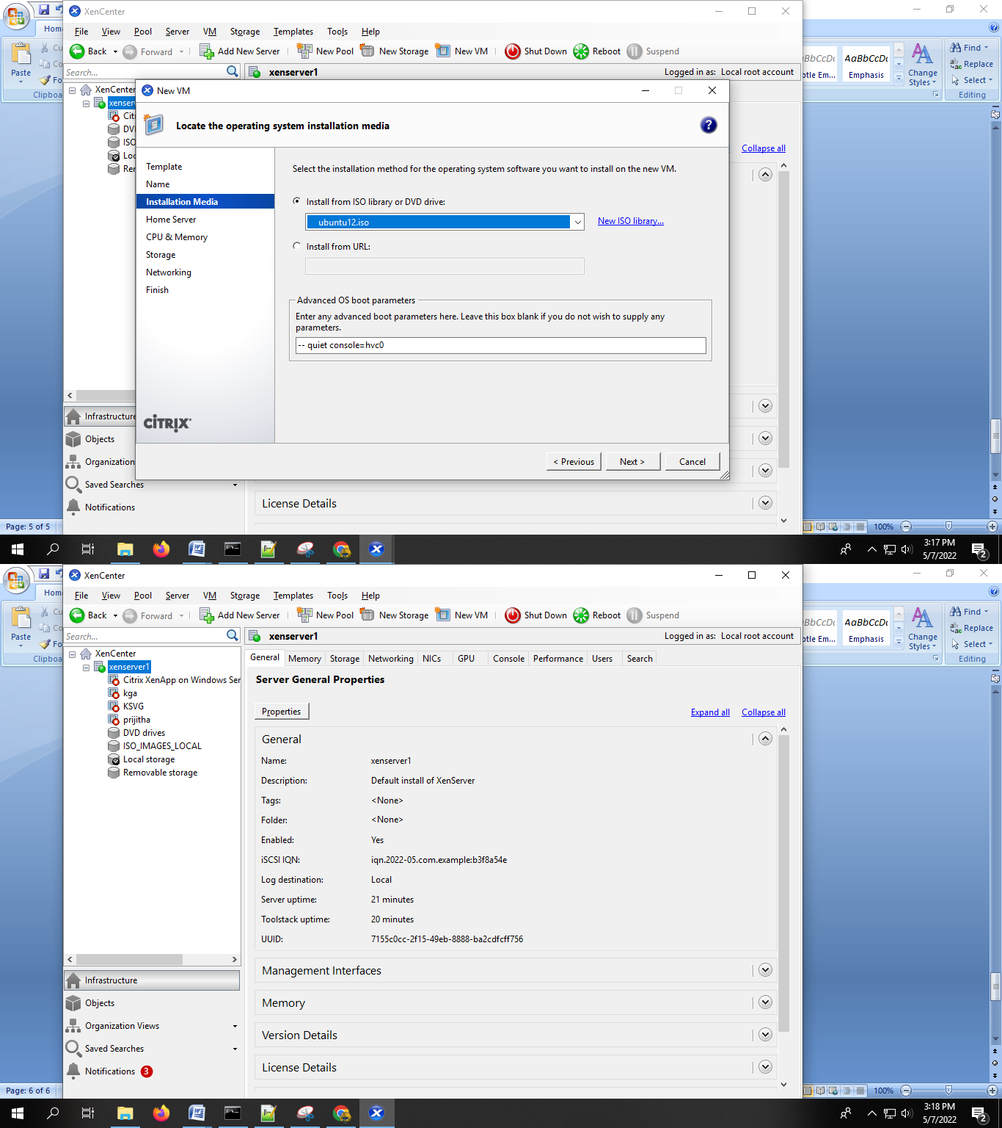

Step 7 : Create a new server , such that you can move the created VM to this server .(same procedure done for creating Xenserver1)

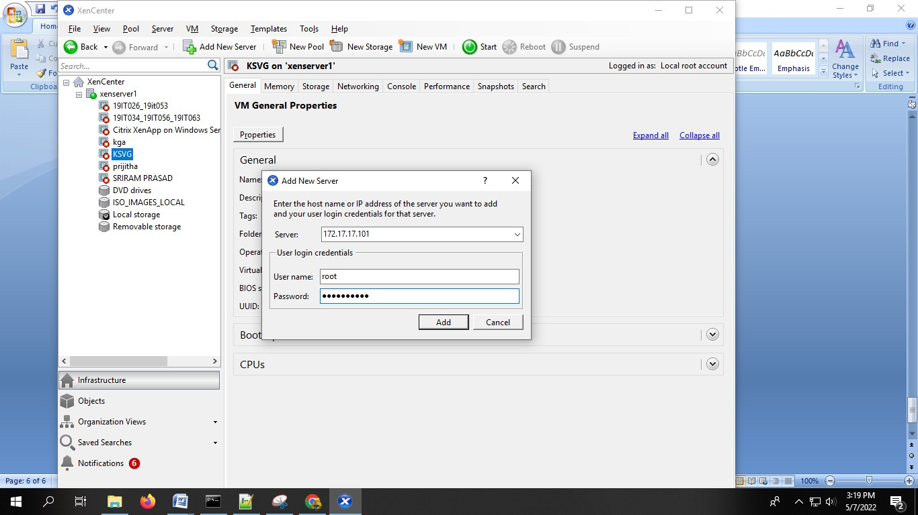

Step 8 : right click you created VM click Move VM.

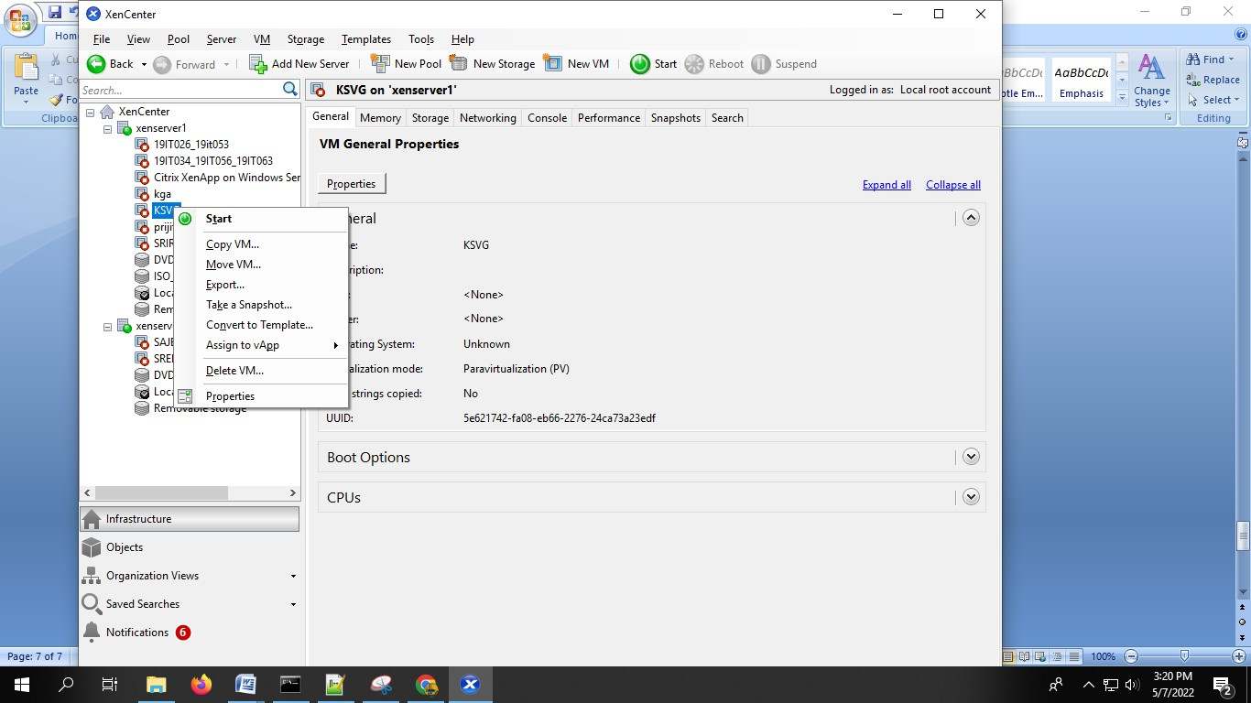

Step 9 : Give xenserver2 as destination and give next. That’s it. The Vm is moved to server2.

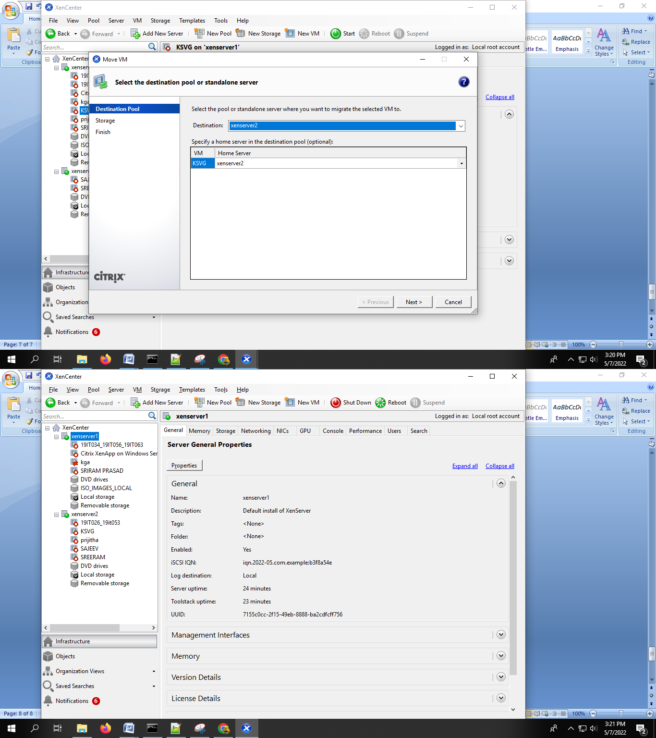

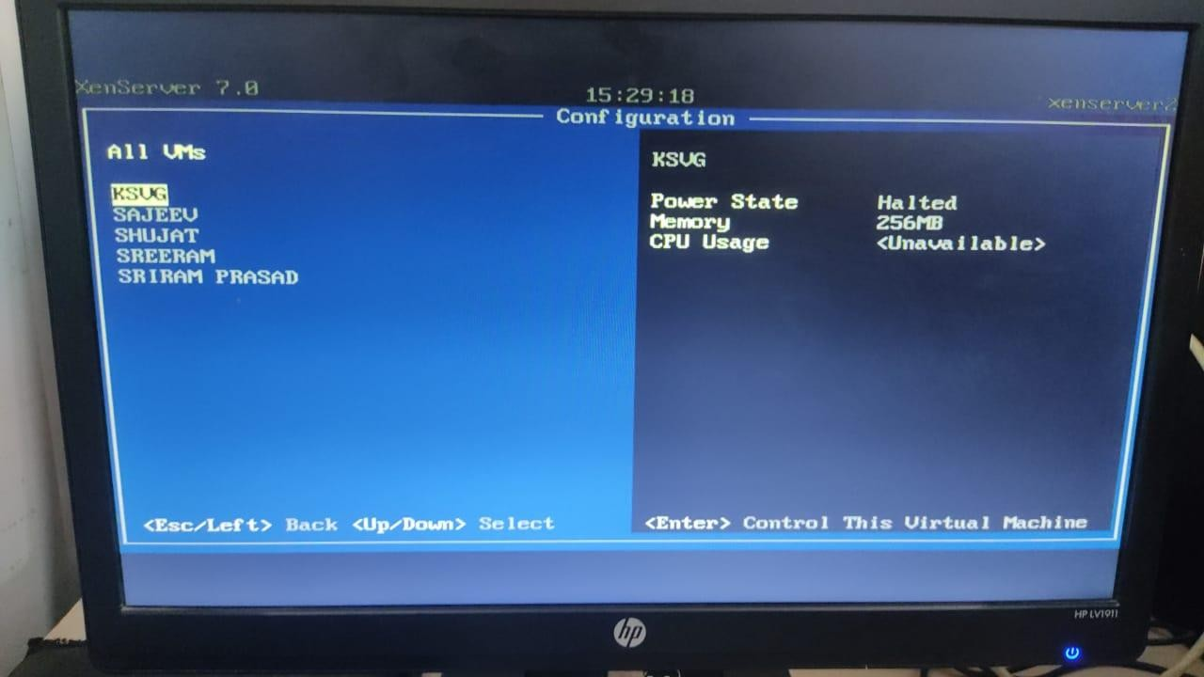

Result :

Thus , the VM is created in Xenserver1 and moved to Xenserver2 using XenServer.